Contents

Buffers 2

PTx.2% (1L) 2

PTwH (1L) 2

Permeabilizing buffer (50mL) 2

Secondary antibodies 2

Sample Collection 2

Embed brain 2

Immunolabeling 3

Clearing tissue 3

Tissue check 4

Antibodies tested 4

Light Sheet Imaging 5

Mount to sample holder 5

Schedule LaVision Ultramicroscope at Microscopy Core with Nikos & Sijie 5

Quantification 5

References 5

|  |  |
| --- | --- |
| Tissue | Estimated completion time  (sack to image) |
| hemisphere brain (Klingberg) | 21 days |
|  |  |

# Buffers

### PTx.2% (1L)

* 100mL PBS 10X (900mL H2O)
* 2mL Tween20 (iDISCO uses tritonX)

### PTwH (1L)

* 100mL PBS 10X
* 2mL Tween-20
* **1mL of 10mg/mL Heparin stock solution**

### Permeabilizing buffer (50mL)

* 42mL PTx.2%
* 3mL of Goat Serum
* **5mL of DMSO**
* **0.1% Sodium azide (0.05 g)**
* **raise to 1% Tween20 (add 0.4mL)**

# Secondary antibodies

Do not use chemical dyes, use ALEXA dyes or fluorescent proteins only (communication with Klingberg)

# Sample Collection

1. Anesthetize the mouse.

2. Perfuse with 10mL PBS.

3. Perfuse with 10mL 4%PFA/PBS.

4. Dissect the brain/organ and trim to the appropriate size.

5. Fix in 1xPBS/4%PFA at 4°C, 2 days with rocking.

6. Wash in PBS on rock: RT 1 hr x 3times.

# Embed brain

1. make 1% agarose in distilled H2O (0.25g 25mL H2O for two brains)
2. Embed brain in 1% agarose.
3. Trim agarose to make a cube (~2mm extending from each surface).
4. Make desired cut (e.g. sagittal midline).
5. Place on opposing sagittal face to ensure flat imaging surface
6. Wash in PBS on rock

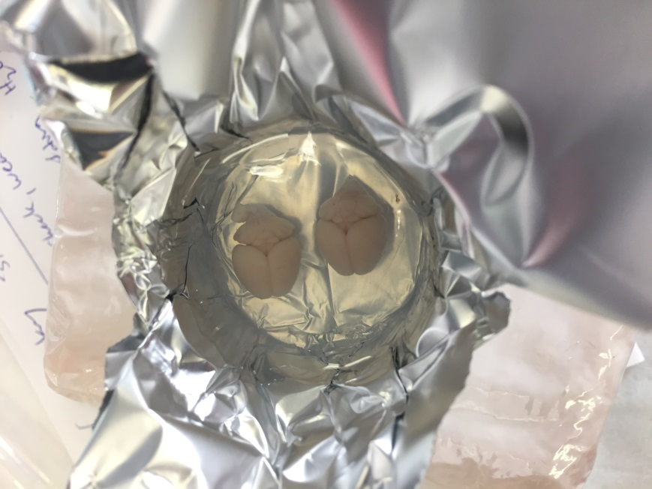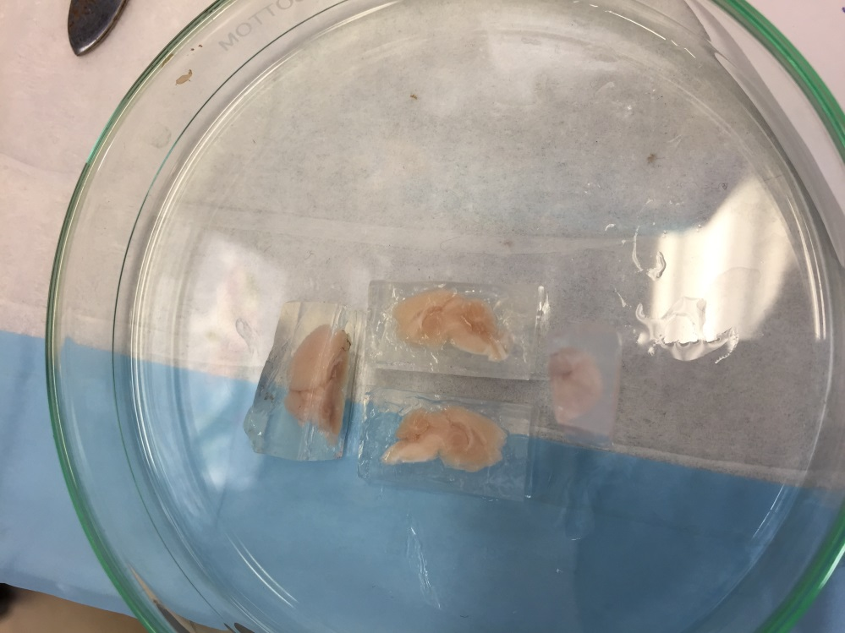

# Immunolabeling

After fixation, wash and embedding:

|  |  |  |  |  |  |  |
| --- | --- | --- | --- | --- | --- | --- |
| Tissue | Bleach 3% H2O2 in PBS1 | Block/Perm soln | 1° antibody, in PTwH/5% DMSO/3% Goat Serum | Wash sample | 2nd antibody, in PTwH/3% Goat Serum | Wash sample |
| hemisphere brain (Klingberg) | O/N rock, wash PTx.2% @ RT | 2 days rock @ 37°C | 7 days on rock @ 37°C | 1 day wash PTwH 5x on rock @ 37°C | 2 days on rock @ 37°C | 1 day wash PTwH 5x on rock then O/N @ 37°C |
| hemisphere brain (iDISCO+) |  | 2 days | 7 days |  | 2 days |  |

1. Bleach in fresh 3%H2O2 in PBS (1 volume 30% H2O2 to 5 volumes PBS).
2. For each vial, make to 6 mL total volume.
3. Heat to 37°C using electric blanket (until we can afford an incubator).

Nutating rocker (<https://www.fishersci.com/shop/products/nutating-mixer-fixed-speed120v/88861041>):

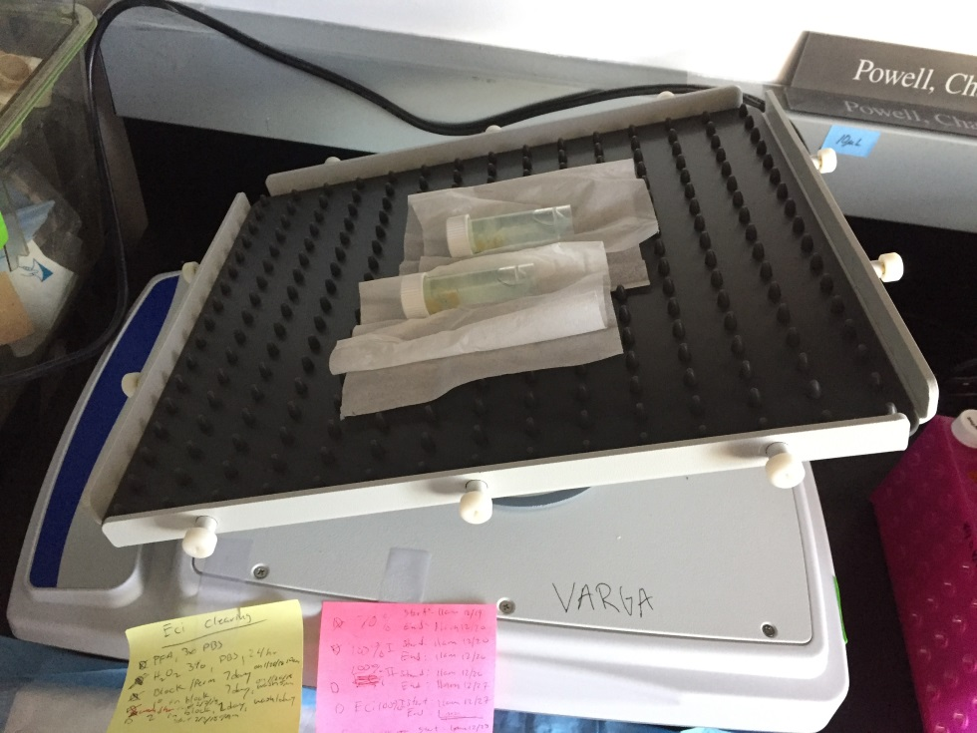

From Blocking step on, use light shield.

# Clearing tissue

After immunolableing:

|  |  |  |  |  |  |
| --- | --- | --- | --- | --- | --- |
| Tissue | 35% EtOH + 2% Tween (pH 9) | 52.5% EtOH + 2% Tween (pH 9) | 70% EtOH + 2% Tween (pH 9) | 3x 100% EtOH + 2% Tween (pH 9) | 2x 100% ECi |
| Whole Brain (Klingberg) | 4hr @ RT | 4hr @ RT | 4hr @ RT | 24hr 2x @ RT | 4hr then O/N each @ RT |
| Whole Brain (iDISCO+) |  |  |  |  |  |

Eg. Make 6mL/vial 🡪 9.6mL EtOH + 2.4mL Tween

# Tissue check

How clear does it look?

Attempt #1 on 121817 🡪 Yellowish

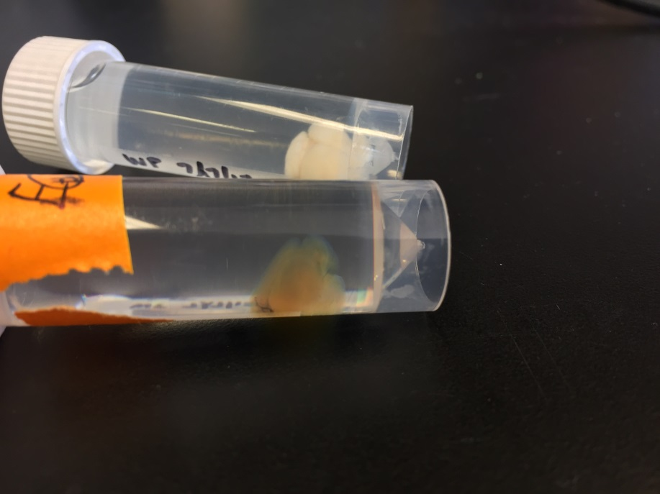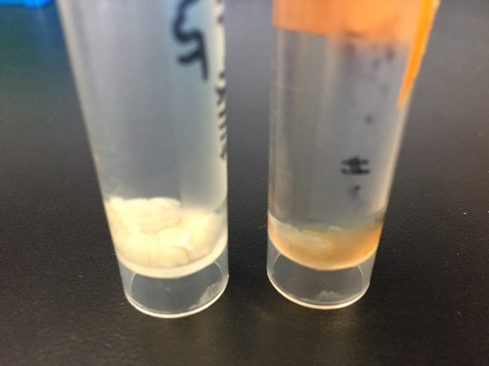

Attempt #2 on 2/12/18 🡪 bleach + minimize air in tubes (6.5mL) 🡪 1:100 TH and 1:100 a647 🡪 too much

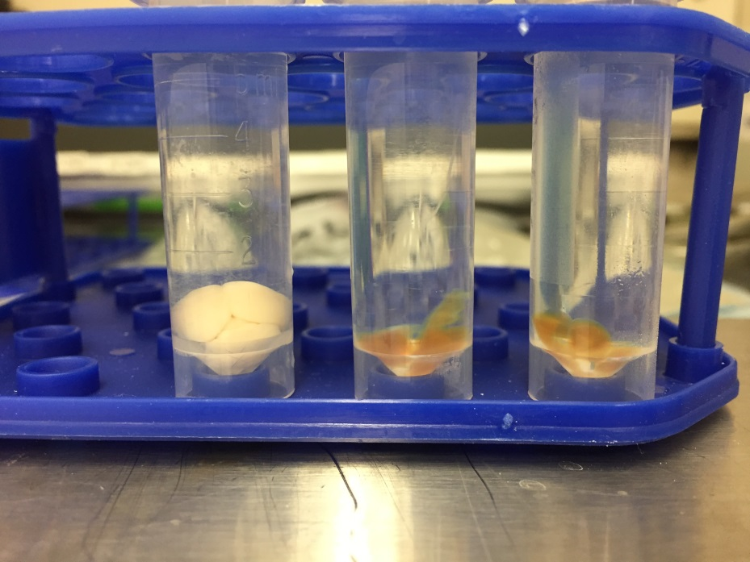

# Antibodies tested

Primaries:

* Tyrosine hydroxylase: 1:100 in 6 mL vial 🡪 60 uL/vial
* Norepinephrine transporter
* dopamine β-hydroxylase
* AT8-human p-tau 🡪 (attempt after successful TH)

Secondaries:

* Secondary Gt Anti-Rb AlexaFluor 647 (A-21245): 1:100 in 6 mL vial 🡪 60 uL/vial

# Light Sheet Imaging

### Mount to sample holder

Use Krazy glue, not locate cyanoacrylate (ECi dissolves this)

### Schedule LaVision Ultramicroscope at Microscopy Core with Nikos & Sijie

(Korey has the account)

* Verify with 1.3x whole sample
* Then max at 4x once verified

# Quantification

* Learn clearmap (but I’ll most likely need access to the Microscopy Core’s server to run a python script on it):
* <https://rawgit.com/ChristophKirst/ClearMap/master/docs/_build/html/index.html>
* Test on trial dataset first (Reneir’s cFos mouse brain).
* IMARIS

# References

* Klingberg et al., Fully Automated Evaluation of Total Glomerular Number and Capillary Tuft Size in Nephritic Kidneys Using Lightsheet Microscopy, 2017.
* Renier et al., Mapping of Brain Activity by Automated Volume Analysis of Immediate Early Genes, 2016.
* Renier et al., iDISCO: a simple, rapid method to immunolabel large tissue samples for volume imaging, 2014.
* <https://idiscodotinfo.files.wordpress.com/2015/04/whole-mount-staining-bench-protocol-methanol-dec-2016.pdf>